Te

School News
Greetings from 1st Grade,
Mrs. Vandegrift and Mrs. Slaubaugh's first graders have been busy this fall learning about the world around them in their science and social studies subjects. We have been specifically focusing on finding locations using maps and globes and really grasping our direction skills. We've also been navigating our studies in learning about the nighttime and daytime skies. They have shown a lot of interest in learning more about constellations, stars, and the moon, so if you get the chance to go outside and grasp God's beautiful sky day or night, I would highly encourage taking that opportunity with them!
This month we will be challenging our students with more math facts including their doubles facts. It is always recommended to get some flashcards and practice at home over holiday breaks to keep their little minds applying and progressing this skill.

We will continue to have spelling tests on Fridays. Upcoming tests will be attentive to special word digraphs working together to make one sound.
Also, our first graders have gotten to enjoy a few art projects over this last month and have shown to be very creative! Whenever they have free time they are always requesting that we draw, cut, or paste. :)
Now that we are through the first quarter of school we will be really challenging our first graders with reading fluency, reading comprehension, sight word retention, and sentence work. I recommend choosing a couple days a week and have them practice these skills at home for about 10 minutes. It is amazing at how much that helps with the progress in the classroom during this time of the year.

Your children are a true blessing to us and have brought a lot of joy to our classroom. They really are a fun and bright group of kids and some days have the kind of energy you wish you could bottle up and save forever! :) Your children really love each and every one of their families and absolutely cherish making memories any time they can with all of you! God's Blessings to you all and Happy Thanksgiving!!
Mrs. Slaubaugh

All Saints Day --- November 1st
All Saints’ Day, which began most likely as All Martyrs’ Day, can be traced to the earliest Christians. By the third century, the followers of Christ were annually honoring their brothers and sisters who had given their lives (been martyred) while witnessing for and defending Jesus Christ. Typically, on the anniversary of a martyr’s death, those living would gather to remember and offer prayers at the tomb or place where the deceased had died. Tombs were sometimes decorated and altars built over the tomb.
All Souls Day --- November 2nd
A day for commemoration of all the faithful departed. The faithful are dedicated to prayer and remembrance of our departed family souls, that they may be with the communion of saints. Many people visit and sometimes decorate the graves of loved ones.

Sacred Heart Newsletter
November 2024
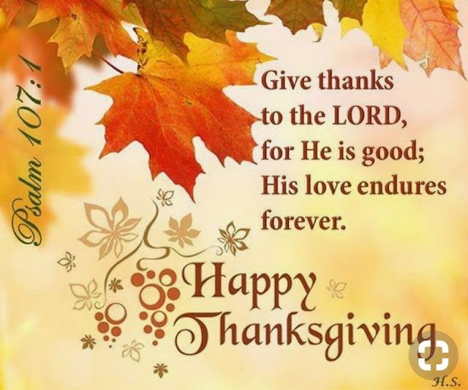

No School – Nov. 1st

Early Release Day – Nov. 6th @ 1:30

No School – Nov. 8th

Thanksgiving Break Nov. 25th – 29th

.
Guardians of Sacred Heart
Operative Campaign

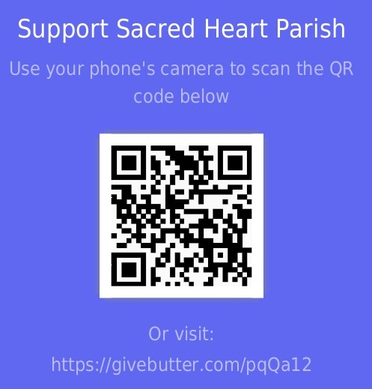

Want to help the school? You can help by making a stand and pledge your monetary support to help further the efforts of making this great school an even better place for Christian education, through the link above. Scan the QR code with your phone and pledge your monetary amount. If you have questions, please call the school office, 785.434.2157

St. Faustina
Sister Faustina (1905-1938) was a young, uneducated nun in a convent of the Congregation of Sisters of Our Lady of Mercy in Poland during the 1930s. She came from a poor family that struggled during the years of World War I. She received extraordinary revelations, or messages from our Lord Jesus. These notebooks are known today as the Diary of Saint Maria Faustina Kowalska, and the words contained within are God's loving message of Divine Mercy. Saint John Paul II canonized Sr. Faustina in 2000 making her the "first saint of the new millennium." The Pope called her "the great apostle of Divine Mercy in our time."
St. Faustina, pray for us.
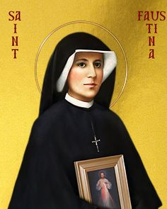
NOVEMBER
1 No School – All Saints Day
4 -7 Diaper Drive & Boxes of Joy
5 Election Day
6 Dismiss @ 1:30
6 Pizza Hut Fundraiser night
8 NO SCHOOL
25 - 29 NO SCHOOL THANKSGIVING BREAK
28 School Council Meeting @ 7:00 pm

Thanksgiving Activities for the Family

Create a gratitude jar, in which everyone jots down what they're thankful for, and share at the meal table.

Get the party started this year with a round of Thanksgiving bingo or Turkey Day Pictionary.

Kick off the holiday season with a cookie swap on Thanksgiving.

Swing by the dollar store or use items from around the house to plan a Thanksgiving scavenger hunt.

++++++++++++++++++++++++

"Now therefore, our God, we thank You and praise Your glorious name"
1 Chronicles 29:13

