Te
Teacher News

Greetings from 2nd grade!
WOW!! Where has the time gone? Seems like we were just beginning the year, now it is close to the end. We have been so busy learning new things. In math we have learned how to tell time and count money. We have also learned to add and subtract with regrouping. We are enjoying the new newspapers that will go with our new science and social studied curriculum. A lot of discussion comes from these. We are excited for the field trip to the Wetlands in Barton County. We would like to thank Mrs. Becker and Mrs. Mongeau for giving us some neat art ideas. They look really neat hanging in our hall! Please continue to have your child practice math facts and read this summer. We have enjoyed teaching your children this year. They are a blessing! Thanks for all your help this year, it has been very much appreciated. We wish all the kids and their families a fun and safe summer! God Bless! Mrs VanDegrift and Mrs. Slaubaugh

Hello from 4th grade!
The 4th graders have been enjoying lessons from our new Kansas Studies Weekly curriculum. They have been learning about early American Indians who lived in the area of Kansas. These include Paleo Indians, Archaic Indians, Woodland Indians, Village Indians, Protohistoric Indians, and Historic Indians. We recently completed the novel Holes by Louis Sachar and have begun our new book titled The Lion, the Witch, and the Wardrobe by C.S. Lewis – very entertaining stories with powerful characters and life lessons. The school year has flown by, and I’ve thoroughly enjoyed getting to know and work with the students at Sacred Heart Grade School
Mr. Bennett



SERVER TRAINING
WED. MAY 1, 2024
7:00 PM
All servers are strongly urged to attend training



Traveling car game ideas:

The License Plate Game (who can spot the most license plates from other states)

Alphabet Game (how many letters can you spot on the billboard signs)

Triple Threat (adults pick out three nouns, kids have to create story using all three nouns)

In My Suitcase (a person starts story “one thing I packed in my suitcase… each person keeps adding items…



Sacred Heart Newsletter
MAY 2024
May Early Release Day – Special Dress
Wednesday, May 1, 2024

.
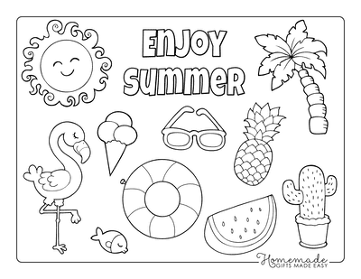

May Calendar

1 Early Dismiss @ 1:30 pm – Crazy Hat Day
1 Pizza Hut Fundraiser night
1 Kindergarten Round-up
3 Health Fair 3rd 12:15 to 3:15
5 First Holy Communion
5 Spring Musical Pre-K 6:00 pm
5 Spring Musical K-5 7:00 pm
6 Ameritowne
6 – 10 Teacher Appreciation Week
7 May & July Birthday’s Lunch
10 4th & 5Th grades Ft. Larned field trip
10 Kdg. field trip to Hays
13 Home & School Potluck
15 Pre-K graduation
16 Report card day
16 Awards Day
16 Dismiss @ 11:30 Last day of School

James 1:17
++++++++++++
“Every good and perfect gift is from above, coming down from the Father of the heavenly lights, who does not change like shifting shadows.”

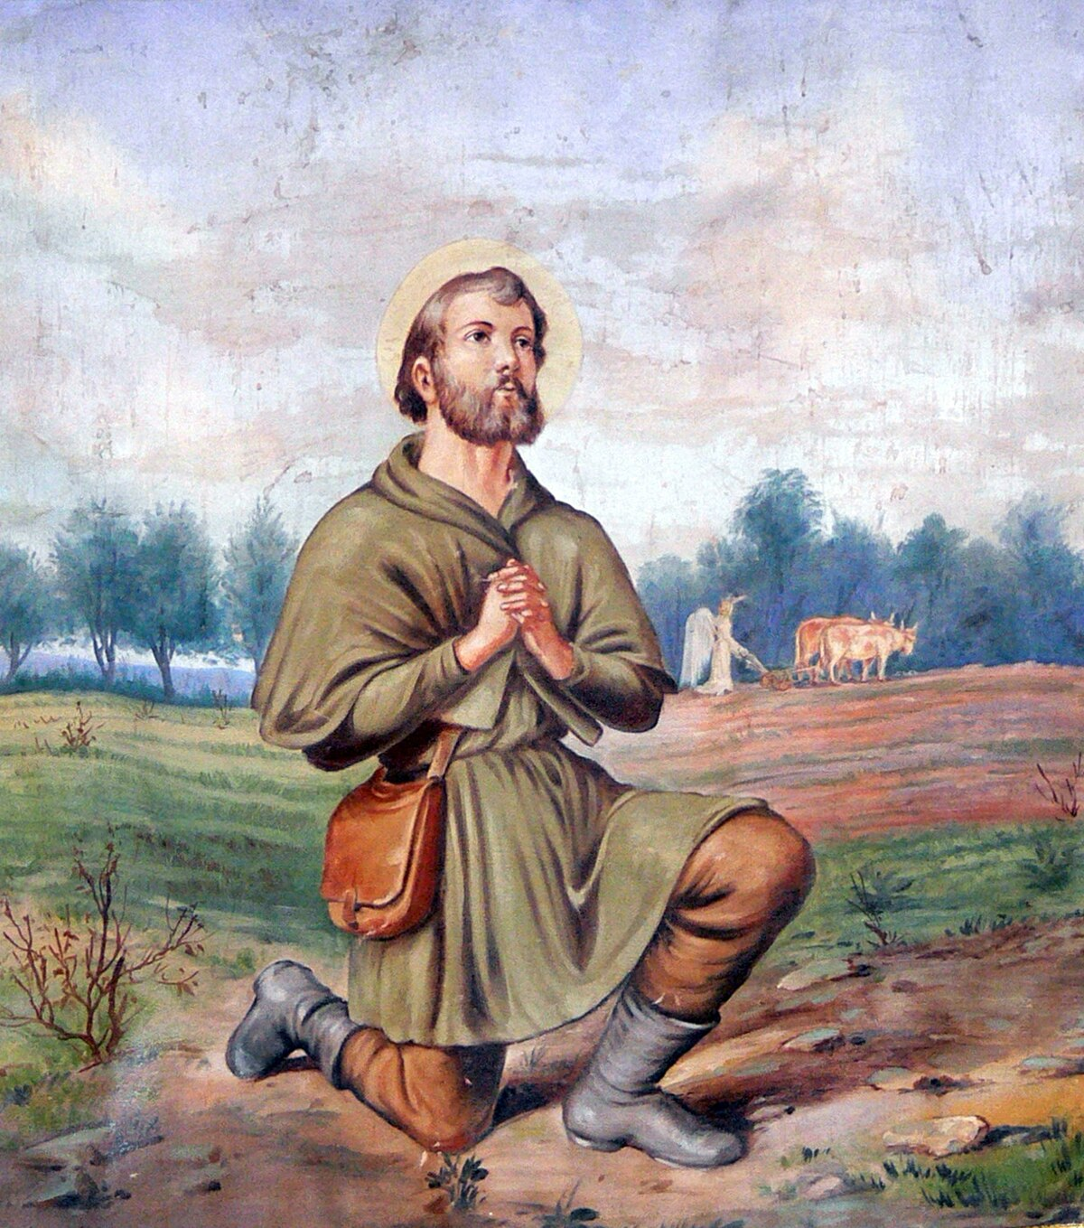
St. Isadore
Patron saint of rain and farmers.
O God, in Whom we live and move, and have our being, grant us rain, in due abundance, that, being sufficiently helped with temporal gifts, we may the more confidently seek after eternal gifts. Through Christ our Lord. Amen

St. Isadore, pray for us.


